Dear Neighbor,

The Saratoga County Citizens Committee for Mental Health (SCCCMH) annual “Mental Health Matters Benefit” event is May 2nd at Longfellows Restaurant. The Mental Health Matters Benefit is the primary fundraiser for the SCCCMH. As part of Mental Health Awareness Month, the SCCCMH will also recognize our “2018 Citizens of the Year”, Ed and Lisa Mitzen.

Our benefit features a silent auction as well as raffles. You can help the SCCCMH by donating an item and/or sponsoring our event. The opportunity for different levels of sponsorship is explained on the attached sponsorship form. All donations will be publicly acknowledged as a donation from your business. Also, since we are a 501(c)(3) charitable corporation, your donation is tax deductible.

SCCCMH’s is a non-profit, charitable organization that distributes grant money to agencies and programs in Saratoga County so they can enrich existing programs or expand services for people living with mental illness. The SCCCMH also provides affordable educational opportunities for professionals and consumers; advocates for improved mental health care and services; and is committed to increasing public awareness.

Please mail your response to the Saratoga County Citizens Committee for Mental Health (SCCCMH),
P.O. Box 820, Saratoga Springs, NY 12866 or feel free to contact us at 518-932-7398 and we will gladly arrange to pick-up your donation. Contact us, too, if you have any questions about the SCCCMH, its activities, or our fundraiser. For more information, you can also visit our website at
www.SCCCMH-Saratoga.org .

We thank you in advance for your generous consideration. Mental Health Matters!

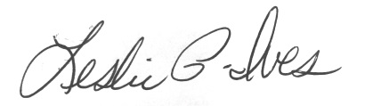
Cordially,

Leslie Ives Christine Hechemy
Benefit Committee Co-Chair Benefit Committee Co-Chair

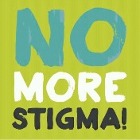
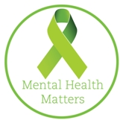
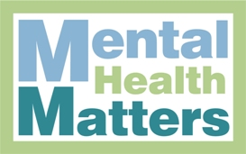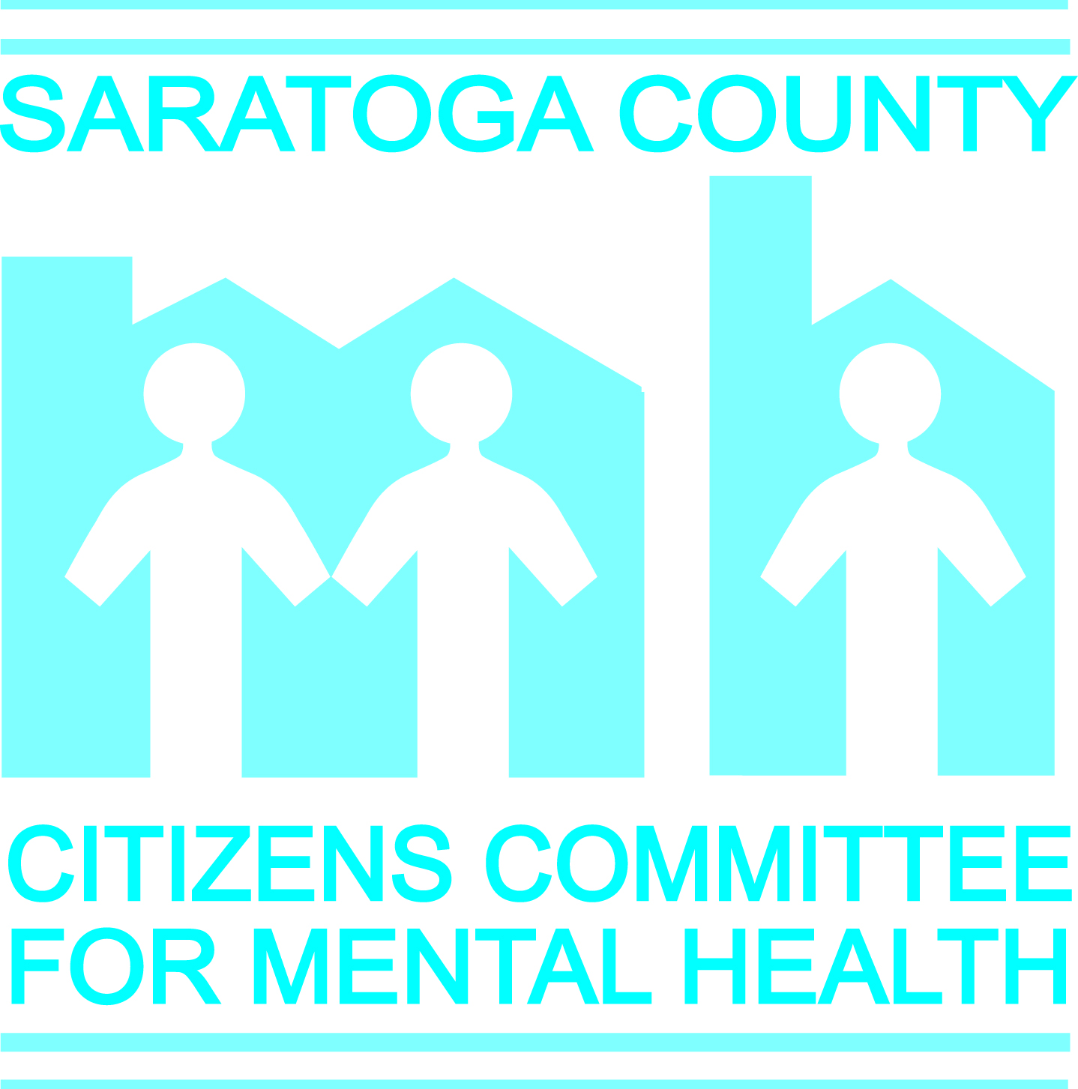
SPONSORSHIP REQUEST FORM
Wednesday, May 2, 2018
Longfellows Restaurant
6:00 – 9:00 pm

Honoring the 2018 Citizens of the Year – Ed and Lisa Mitzen

Appetizers – Buffet Dinner – Dessert
Silent Auction – Raffles
******************************************************
Mental Health Champion: $1000.00
Mental Health Partner: $500.00
Mental Health Supporter: $250.00
(refer to the Sponsorship Recognition Levels for more information)

Name(s):
Address:
City: State: Zip:

Phone: E-mail:

Amount Enclosed $

Submit Sponsorship Request form by April 1st to ensure recognition in event publicity by sending and check payable to:
SCCCMH, PO Box 820, Saratoga Springs, NY 12866.
For questions or more info, call Leslie Ives at 518-932-7398 or
e-mail: info@SCCCMH-Saratoga.org
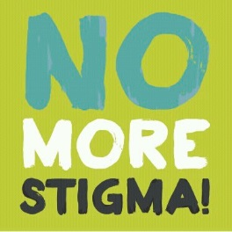
SPONSORSHIP RECOGNITION LEVELS

Mental Health Champion: $1000.00
Mental Health Partner: $500.00
Mental Health Supporter: $250.00

$1,000 – Mental Health Champion
• Verbal recognition during remarks
• Special recognition in event press release
• Logo on event poster
• Special recognition on the SCCCMH Facebook page
• Eight (8) complimentary reservations
• Link to your web page from the SCCCMH-Saratoga webpage.
• ¼ Page Ad and special recognition in SCCCMH Fall Newsletter

$500 – Mental Health Partner
• Verbal recognition during remarks
• Special recognition in event press release
• Special recognition on the SCCCMH Facebook Page
• Logo on event poster
• Four (4) complimentary reservations
• Recognition in SCCCMH Fall Newsletter

$250 – Mental Health Supporter
• Special recognition in event press release
• Logo on event poster
• Two (2) complimentary reservations
• Recognition in SCCCMH Fall Newsletter

