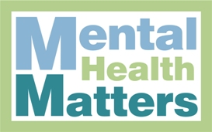
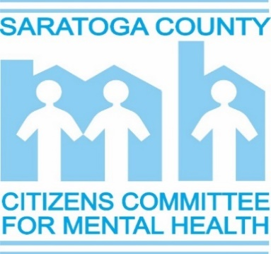
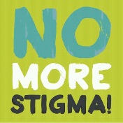
Benefit Fundraiser

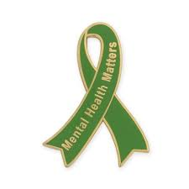
Saturday, April 29, 2023
Saratoga-Wilton Elks Lodge
6:00 – 10:00 pm (Reservations Required)
Honoring Citizen of the Year:
Dr. Donna Cohen, Psychiatrist
Saratoga Hospital Medical Group – Inpatient Mental Health

Buffet Stations – 6 to 7:30 pm, Cash Bar 6 to 10 pm, Program 7:30 to 8 pm,
Photobooth 6 to 10 pm, Dancing 8 to 10 pm, Raffle Drawing 8 pm
DJ Music Entertainment, 6 to 10 pm, provided by Michael Rafferty
******************************************************
Basic Reservation is $45.00 per person
Discounted Reservation is $15.00 per person (if needed)
Consider one of these special reservations to help SCCCMH reach our goal:
Honorary Committee: $100.00 per person
Advocate: $55.00 per person Friend: $65.00 per person
Honorary Committee, Advocates and Friends will be recognized at the Benefit.
Value of goods and services $30.00
Name(s):
Address:
City: State: Zip:

Phone: Email:

Number of Persons Attending: Amount Enclosed $

I am unable to attend but enclosed is my donation of $
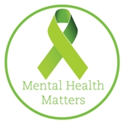
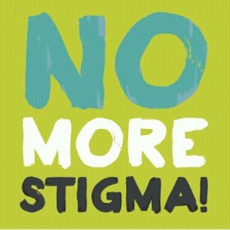
RSVP by April 18, 2023 by sending reservations and check payable to:
SCCCMH, PO Box 820, Saratoga Springs, NY 12866.
For questions or more info,
Call SCCCMH Chairperson, Peggy Lounsbury, at 518-583-8371 or
e-mail: info@SCCCMH-Saratoga.org

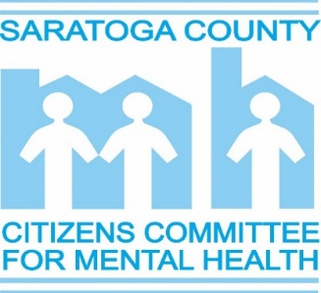

The Saratoga County Citizens Committee for Mental Health (SCCCMH), also known as “the Citizens Committee”, was founded in 1969 and incorporated in 1970 as a charitable organization. The Committee is a volunteer organization devoted to promoting improved care and services for people living with mental illness in Saratoga County.
Previously named the Activity Program Volunteers, the original dedicated group of individuals was committed to enhancing self-esteem and increasing socialization for the mentally ill, who many times remained isolated from their communities. From this, came an endowment to support the program and the establishment of the SCCCMH as a charitable organization.
Today, the SCCCMH uses the endowment to provide grants up to $1,000 to agencies and programs in Saratoga County that provide services to the mentally ill community. In addition, the Committee provides educational opportunities for mental health professionals and consumers. Through these and other activities, the SCCCMH advocates for, and increases awareness of, the needs of people living with mental illness. Although the SCCCMH does not provide mental health services or care, the Committee is the primary voice and advocate for the needs of people living with mental illness in Saratoga County.
Our mission:
Increase Awareness: Increase public awareness of the needs of mental health community, i.e., increase access to public transportation, affordable housing, and decrease the stigma associated with mental illness.
Education: Provide affordable educational opportunities for mental health professionals, families, and consumers of mental health services.
Advocacy: Advocate for improved mental health care and services by lobbying government and elected officials.
Program Development and Enrichment: The SCCCMH awards grants, usually up to $1,000, to agencies and programs in Saratoga County so they can enrich existing programs or expand services for people living with mental illness.
Become a part of the Voice of Saratoga County Mental Health Community...Join SCCCMH Today! Visit our website: www.SCCCMH-Saratoga.org
The Saratoga County Citizens Committee for Mental Health is a 501(c)(3) charitable organization. Federal Tax ID # 23-7091953

